WIPO IP Protection Platform

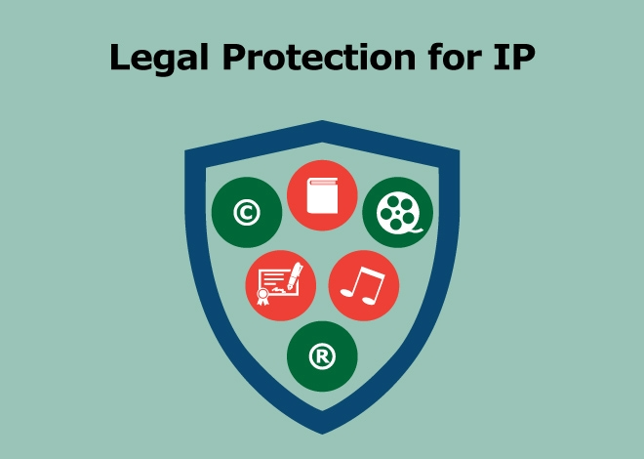

WIPO IP Protection Platform - A Blockchain-Based Digital Intellectual Property Protection System with AI-Powered Search
Arielle-Milan Tchalieu Ngomsi
May 2026

5287 words
64 pages

Table of Contents
Table of Contents 2
Table of Figures 7
Project Overview 8
Project Description: 8
Problem Statement: 8
Overall Project Objectives: 8
Key Features: 8
System Architecture 10
Basic Architecture: 10
High-Level Architecture: 11
Data Flow Architecture: 12
Technology Stack 13
Frontend: 13
Backend: 13
AI & Search: 13
Database: 13
Security: 13
Folder Structure 14
UML Diagrams 17
Use Case Diagram: 17
Class Diagram: 18
Sequence Diagram: 19
Installation & Setup Guide 20
Prerequisites: 20
Step 1: Create Project and Setup the Backend 21
Step 2: Frontend Setup 28
Step 3: Run Migrations and Start Servers 30
Backend Directory: 30
Frontend Directory: 31
Step 4: Create the Environment Variables 31
backend/.env: 31
frontend/.env: 31
Step 5: Configuration Files 32
Configure the backend/config/settings.py File: 32
Configure the backend/config/urls.py File 32
Phase 1: Backend Implementation 33
Step 1: Accounts App 33
Configure the backend/apps/accounts/models.py File 33
Configure the backend/apps/accounts/serializers.py File 33
Configure the backend/apps/accounts/views.py File 33
Configure the backend/apps/accounts/urls.py File 33
Step 2: Works App 34
Configure the backend/apps/works/models.py File 34
Configure the backend/apps/works/services.py File 34
Configure the backend/apps/works/views.py File 34
Configure the backend/apps/works/urls.py File 34
Step 3: Alerts App 35
Configure the backend/apps/alerts/models.py File 35
Phase 2: Frontend Implementation 35
Step 1: Vite Configurations 35
Configure the frontend/vite.config.js File 35
TailwindCSS Configuration 35
Configure the frontend/tailwind.config.js File 35
Configure the frontend/src/index.css File 35
Step 2: API Client 36
Configure the frontend/src/api/client.js File 36
Step 3: Auth Context 36
Configure the frontend/src/context/AuthContext.jsx File 36
Step 4: Layout Component 36
Configure the frontend/src/components/Layout.jsx 36
Step 5: Pages 36
Configure the frontend/src/pages/Login.jsx File 36
Configure the frontend/src/pages/Register.jsx File 37
Configure the frontend/src/pages/Dashboard.jsx File 37
Configure the frontend/src/pages/UploadWork.jsx File 37
Configure the frontend/src/pages/SearchWorks.jsx File 37
Step 6: Main App Component 38
Configure the frontend/src/App.jsx File 38
Configure the frontend/src/main.jsx File 38
Phase 3: AI-Powered Search 39
Step 1: Search Service 39
Configure the backend/apps/works/search_services.py File 39
Step 2: Add Search View 39
Configure the backend/apps/works/views.py File 39
Step 3: Update URLs 39
Configure the backend/apps/works/urls.py File 39
Phase 4: Blockchain Integration 40
Step 1: Blockchain Service 40
Configure the backend/apps/blockchain/services.py File 40
Step 2: Blockchain Views 40
Configure the backend/apps/blockchain/views.py File 40
Step 3: Blockchain URLs 40
Configure the backend/apps/blockchain/urls.py File 40
Phase 5: Testing & Quality Assurance 41
Step 1: Running Tests 41
Backend Tests: 41
Frontend Tests: 41
Phase 6: Azure Deployment 43
Deployment Overview: 43
Step 1: ZIP Project Folder 43
Step 2: Deploy Backend to Azure App Service 43
Deployment Script: `deploy-azure.ps1` 43
Step 3: Deploy Backend (Django API) to Azure App Service 43
Login to Azure Portal: 43
Create a Subscription: 43
Create a Resource Group: 44
Create App Service (Web App): 45
Wait for Deployment: 46
Upload Your Backend Code (Using FTPS): 46
Configure Environment Variables 47
Run Database Migrations 47
Restart the App 48
Step 4: Deploy Frontend (React) to Azure Storage 48
Create Storage Account: 48
Enable Static Website Hosting: 48
Upload Your Frontend Files: 48
Update Backend CORS Settings: 49
Step 5: Verify Your Deployment 49
Test Backend API: 49
Test Frontend: 49
Test Full Flow: 49
Step 6: URLs After Deployment 49
API Documentation 50
Authentication Endpoints: 50
Register Request Body: 50
File Contents 50
Login Response: 50
File Contents 50
Works Endpoints: 50
Upload Request (multipart/form-data): 51
Upload Response: 51
File Contents 51
Dashboard Response: 51
File Contents 51
Search Response: 52
File Contents 52
Blockchain Endpoints 52
Response: 52
File Contents 52
Error Responses: 53
Error Response Format: 53
File Contents 53
Challenges I Faced 54
Challenge 1: Installing Pillow (Backend Setup) 54
Problem: 54
Root Cause and Solution: 54
Challenge 2: Installing Tailwindcss (Frontend Setup) 55
Problem: 55
Root Cause and Solution: 55
Conclusion 57
Project Summary: 57
Skills Demonstrated: 57
Technical Skills 57
Soft Skills 57
Future Enhancements: 57
References 59
Tools & Libraries: 59
Backend Dependencies 59
Frontend Dependencies 59
Appendices 60
Appendix A: Quick Commands Reference 60
Start Backend: 60
Start Frontend: 60
Create Migrations: 60
Create Superuser: 60
Run Tests: 60
Deploy to Azure: 60
Appendix B: Environment Variables 61
Backend .env: 61
Frontend .env: 61
Azure Production Settings: 61
Appendix C: Project Timeline 61
Appendix D: Final Deployment URLs 61

Table of Figures
Figure 1: Basic Architecture Diagram 8
Figure 2: High-Level Architecture Diagram 9
Figure 3: Data Flow Architecture Diagram 10
Figure 4: Use Case Diagram 15
Figure 5: Class Diagram 16
Figure 6: Sequence Diagram (Upload Work) 17
Figure 7: Verify installations 19
Figure 8: Create Project and Setup the Backend 25
Figure 9: Create React Project 27
Figure 10: Run migrations in the backend 29
Figure 11: Start frontend server 29
Figure 12: Running the backend tests 39
Figure 13: Running the frontend tests 40
Figure 14: Create a Subscription 42
Figure 15: Create a Resource Group 43
Figure 16: Create the App Service (Web App) 44
Figure 17: Pillow installation fixed 53
Figure 18: Error installing Tailwindcss 53
Figure 19: Fixing Tailwind CSS 54

Project Overview

Project Description:
The WIPO IP Protection Platform is a comprehensive web-based solution that enables creators, startups, and innovators to protect their intellectual property through digital timestamping using SHA-256 hashing, blockchain verification for immutable ownership records, and automated infringement detection. The platform provides an accessible, secure, and verifiable way to prove ownership of digital works.

Problem Statement:
Problem: | Impact: | Current Solution Gap:
Expensive IP registration | Most creators can't afford | Traditional methods cost $500+
Difficulty proving ownership | Works are easily copied | No cheap timestamping available
No automated infringement detection | Creators unaware of copies | Manual searching is impossible
Complex technical requirements | Non-technical users excluded | Most solutions require coding

Overall Project Objectives:
Objective: | Description: | Success Metric:
Digital Timestamping | SHA-256 proof of creation | Hash generation < 5 seconds
Ownership Tracking | Blockchain-based records | Immutable verification
Infringement Detection | Automatic duplicate alerts | Real-time detection
AI-Powered Search | Find similar registered works | < 2 seconds per search
User Accessibility | Intuitive web interface | < 3 clicks to upload
Cloud Deployment | Scalable 24/7 hosting | 99.9% uptime

Key Features:
Feature | Technology | Description
JWT Authentication | SimpleJWT | Secure user login/registration
SHA-256 Hashing | hashlib | Cryptographic file fingerprinting
Blockchain Ledger | Custom Python | Immutable record of all registrations
Infringement Alerts | Hash matching | Automatic duplicate detection
React Dashboard | Vite + Tailwind | Modern responsive UI
File Storage | Django Media | Secure file uploads

System Architecture

Basic Architecture:
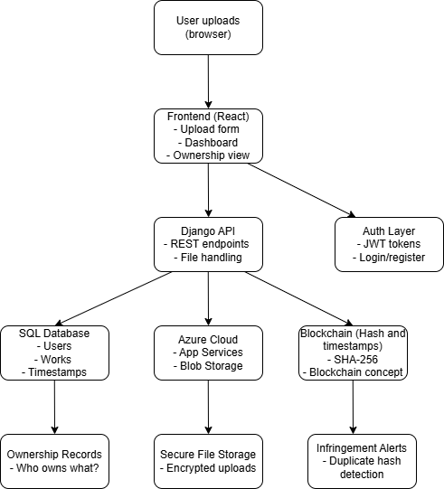
Figure 1: Basic Architecture Diagram

High-Level Architecture:
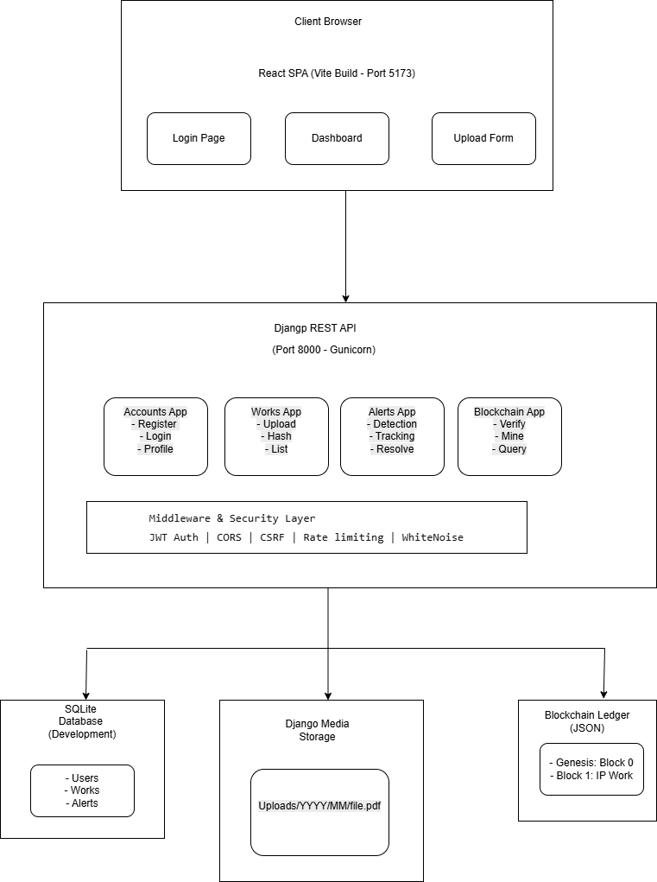
Figure 2: High-Level Architecture Diagram

Data Flow Architecture:
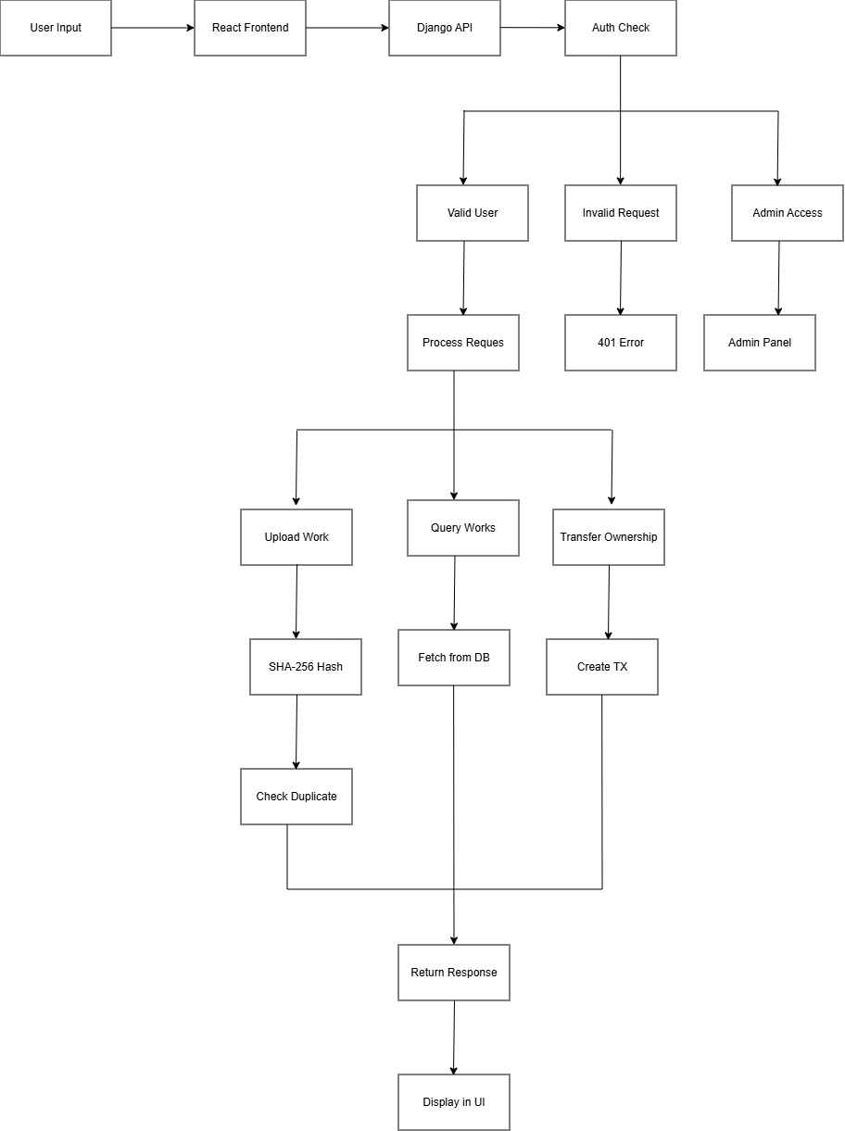
Figure 3: Data Flow Architecture Diagram

Technology Stack

Frontend:
- React: UI Framework.
- Vite: Build Tool.
- TailwindCSS: Styling.
- Axios: HTTP Client.
- React Router DOM: Routing.

Backend:
- Django: Web Framework.
- Django REST: API Development.
- SimpleJWT: JWT Authentication.

AI & Search:
- Scikit-learn: TF-IDF Similarity.
- NumPy: Numerical operations.

Database:
- SQLite: Development.

Security:
- SHA-256: File Hashing.
- JWT: Authentication.

Folder Structure
wipo-ip-platform/
│
├── backend/ # Django Backend Root
│ ├── apps/
│ │ ├── accounts/ # User authentication
│ │ │ ├── __init__.py
│ │ │ ├── admin.py
│ │ │ ├── models.py
│ │ │ ├── serializers.py
│ │ │ ├── urls.py
│ │ │ ├── views.py
│ │ │ └── tests.py
│ │ ├── works/ # IP Work management
│ │ │ ├── __init__.py
│ │ │ ├── admin.py
│ │ │ ├── models.py
│ │ │ ├── serializers.py
│ │ │ ├── services.py
│ │ │ ├── search_services.py # AI Search
│ │ │ ├── urls.py
│ │ │ ├── views.py
│ │ │ └── tests.py
│ │ ├── alerts/ # Infringement detection
│ │ │ ├── __init__.py
│ │ │ ├── admin.py
│ │ │ ├── models.py
│ │ │ ├── serializers.py
│ │ │ ├── urls.py
│ │ │ ├── views.py
│ │ │ └── tests.py
│ │ └── blockchain/ # Blockchain implementation
│ │ ├── __init__.py
│ │ ├── admin.py
│ │ ├── services.py
│ │ ├── urls.py
│ │ ├── views.py
│ │ └── tests.py
│ ├── config/
│ │ ├── __init__.py
│ │ ├── settings.py
│ │ ├── urls.py
│ │ └── wsgi.py
│ ├── media/ # Uploaded files
│ ├── staticfiles/ # Collected static files
│ ├── blockchain_ledger.json # Blockchain data
│ ├── manage.py
│ ├── requirements.txt
│ └── .env
│
├── frontend/ # React Frontend
│ ├── src/
│ │ ├── components/
│ │ │ └── Layout.jsx
│ │ ├── pages/
│ │ │ ├── Login.jsx
│ │ │ ├── Register.jsx
│ │ │ ├── Dashboard.jsx
│ │ │ ├── UploadWork.jsx
│ │ │ └── SearchWorks.jsx
│ │ ├── api/
│ │ │ └── client.js
│ │ ├── context/
│ │ │ └── AuthContext.jsx
│ │ ├── App.jsx
│ │ ├── main.jsx
│ │ └── index.css
│ ├── index.html
│ ├── package.json
│ ├── vite.config.js
│ └── tailwind.config.js
│
├── mobile/ # React Native App
│ ├── src/
│ ├── screens/
│ └── App.js
│
├── .gitignore
└── README.md

UML Diagrams

Use Case Diagram:
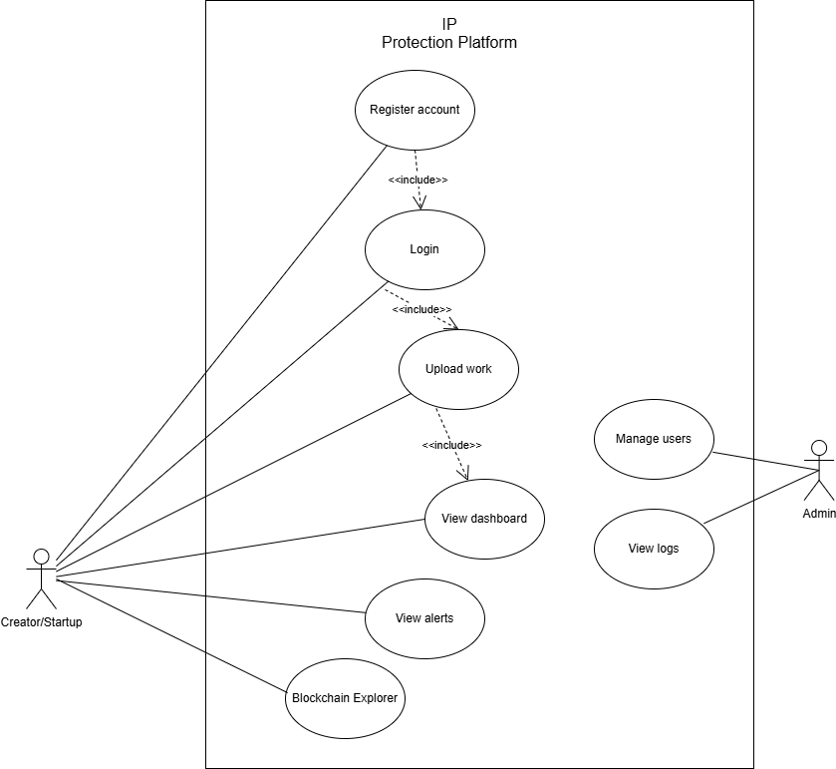
Figure 4: Use Case Diagram

Class Diagram:
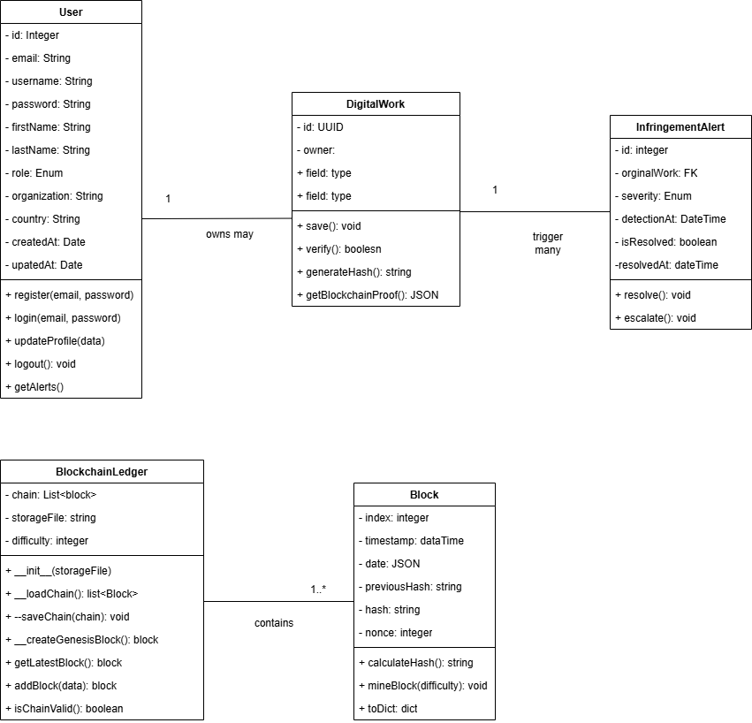
Figure 5: Class Diagram

Sequence Diagram:
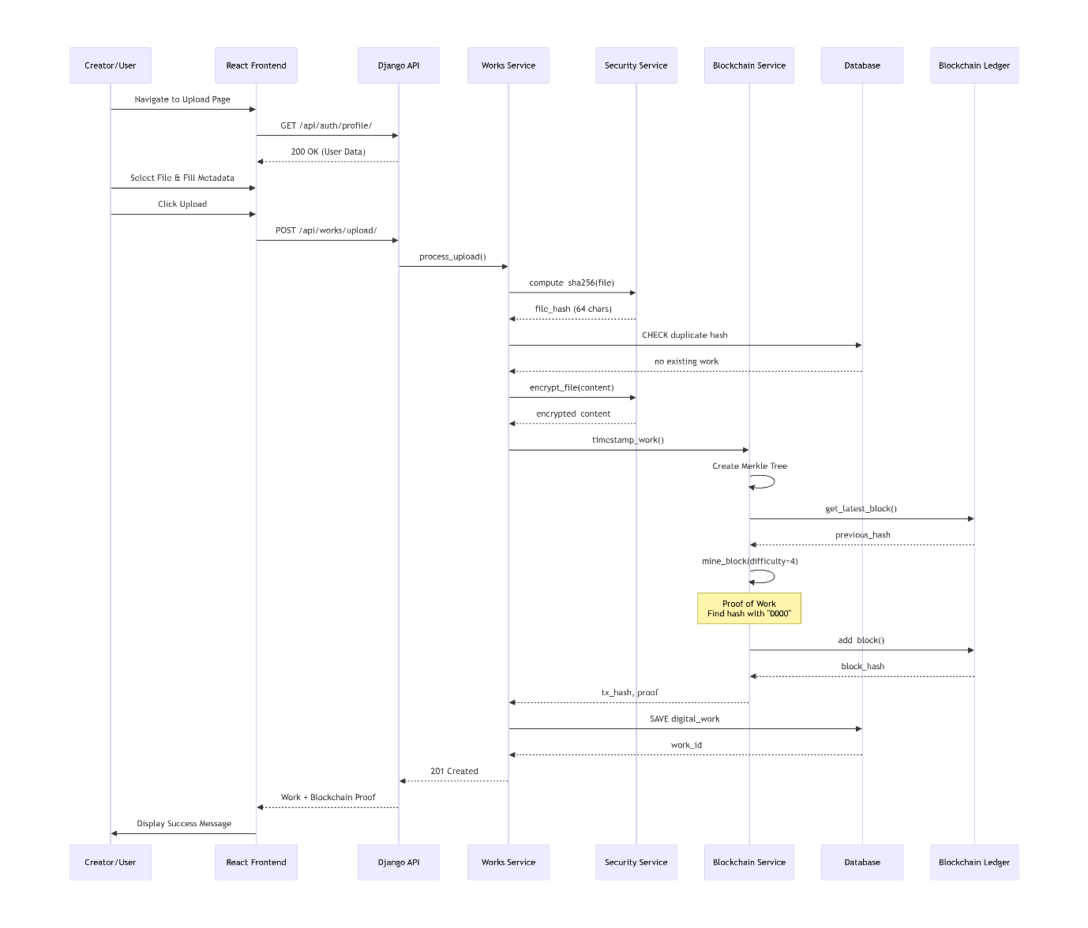
Figure 6: Sequence Diagram (Upload Work)

Installation & Setup Guide

Prerequisites:
I installed the following software:
- Python 3.11: https://www.python.org/downloads/release/python-3119/.
- Check "Add Python to PATH" during installation
- Node.js 20: https://nodejs.org/
- Git: https://git-scm.com/
- VS Code: https://code.visualstudio.com/

azure: https://aka.ms/installazurecliwindows

Then within the terminal, I verified the installations.

Commands Used
python --version
node --version
npm --version
git --version
code --version
az --version

Screenshot of Output
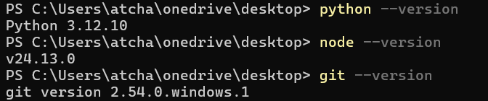
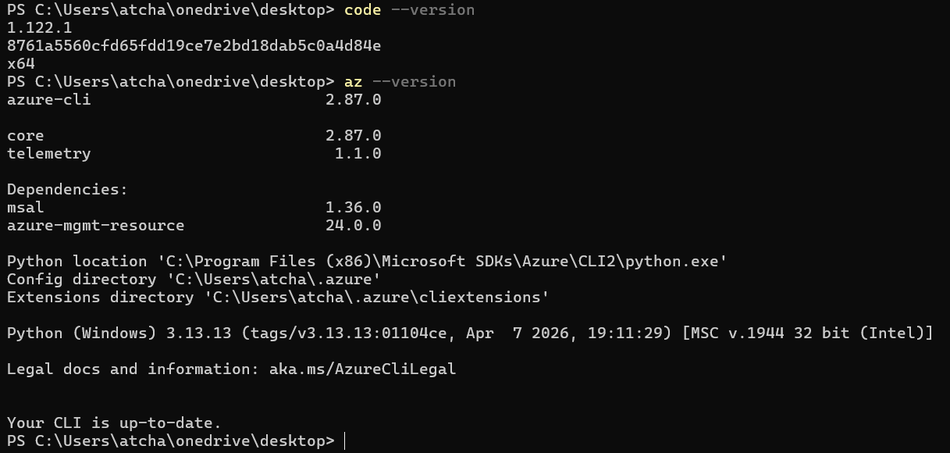
Figure 7: Verify installations

Step 1: Create Project and Setup the Backend
Within the terminal, I did the following:
- Created the project directory.
- Created the backend directory.
- Created the virtual environment.
- Activated the virtual environment.
- Upgraded the pip and install setuptools.
- Installed the Django and core packages.
- Installed the AI packages.
- Created the requirements.txt.
- Created the Django project.
- Created the Django apps.
- Created the apps directory and move apps.
- Created the __init__.py files.
- Created the migrations folders.

Commands Used
mkdir wipo-ip-platform
cd wipo-ip-platform

mkdir backend
cd backend

python -m venv venv

venv\Scripts\activate

python -m pip install --upgrade pip setuptools wheel

pip install Django==4.2.7
pip install djangorestframework==3.14.0
pip install djangorestframework-simplejwt==5.3.0
pip install django-cors-headers==4.3.1
pip install python-dotenv==1.0.0
pip install Pillow==10.0.1

pip install scikit-learn==1.3.0
pip install numpy==1.24.3
pip install pandas==2.0.3

pip freeze > requirements.txt

django-admin startproject config .

python manage.py startapp accounts
python manage.py startapp works
python manage.py startapp alerts
python manage.py startapp blockchain

mkdir apps
move accounts apps\
move works apps\
move alerts apps\
move blockchain apps\

echo. > apps\__init__.py
echo. > apps\accounts\__init__.py
echo. > apps\works\__init__.py
echo. > apps\alerts\__init__.py
echo. > apps\blockchain\__init__.py

mkdir apps\accounts\migrations
mkdir apps\works\migrations
mkdir apps\alerts\migrations
mkdir apps\blockchain\migrations

echo > apps\accounts\migrations\__init__.py
echo > apps\works\migrations\__init__.py
echo > apps\alerts\migrations\__init__.py
echo > apps\blockchain\migrations\__init__.py

Screenshot of Output
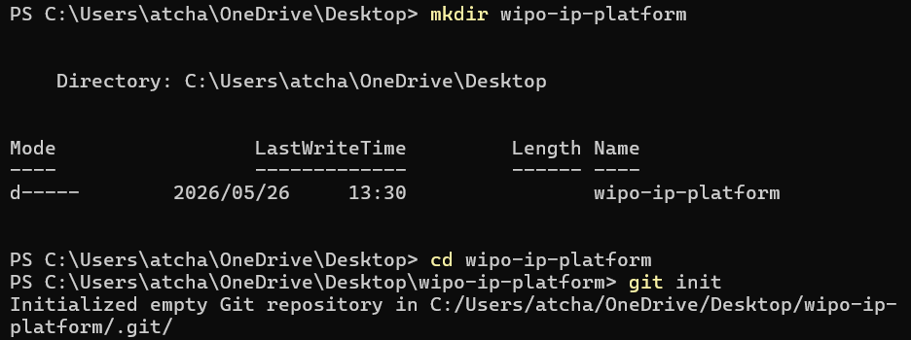
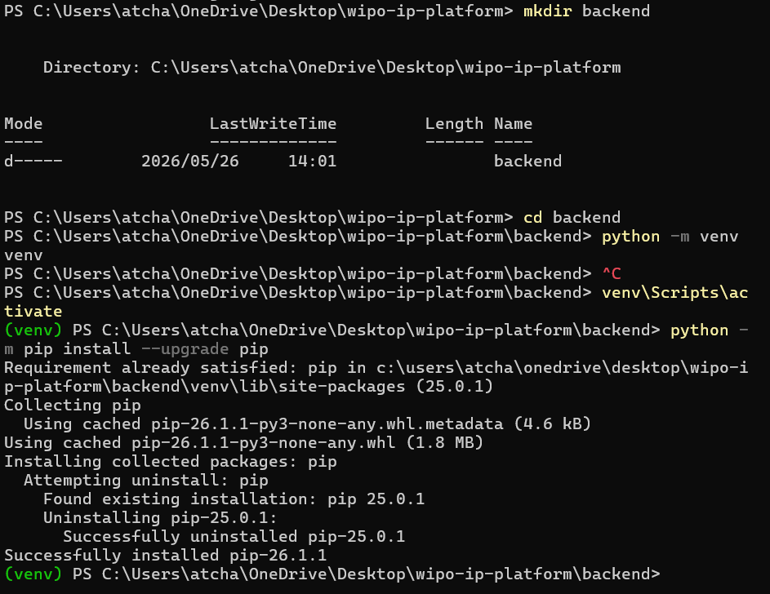
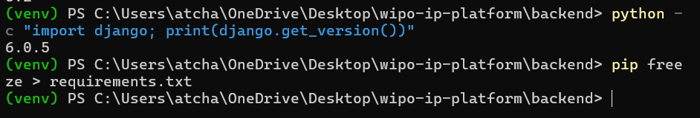
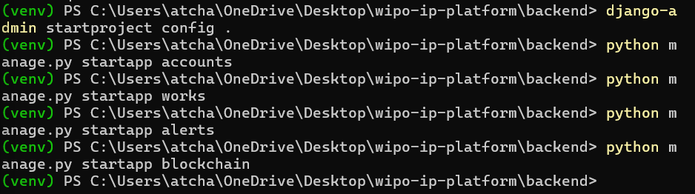
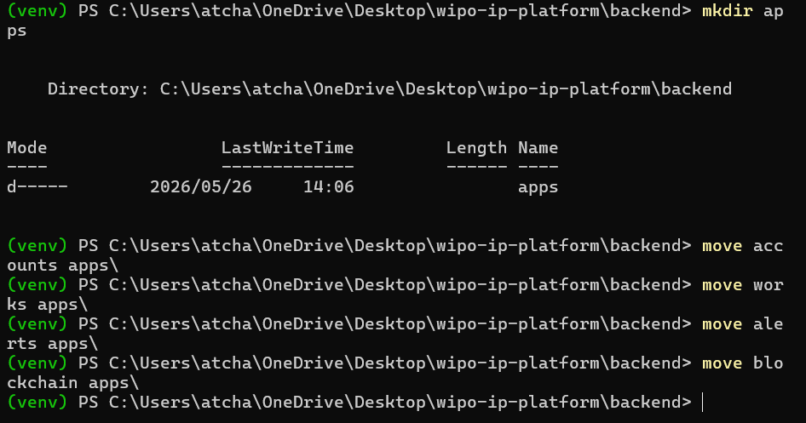
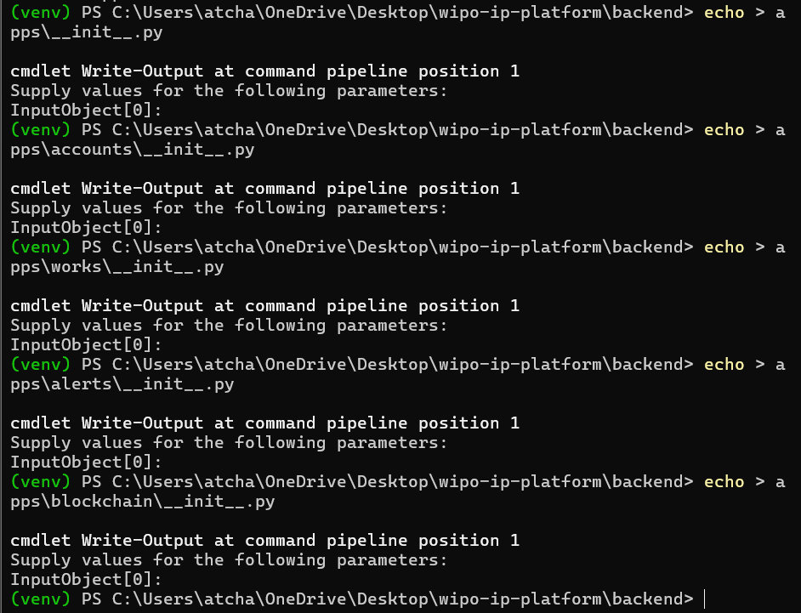
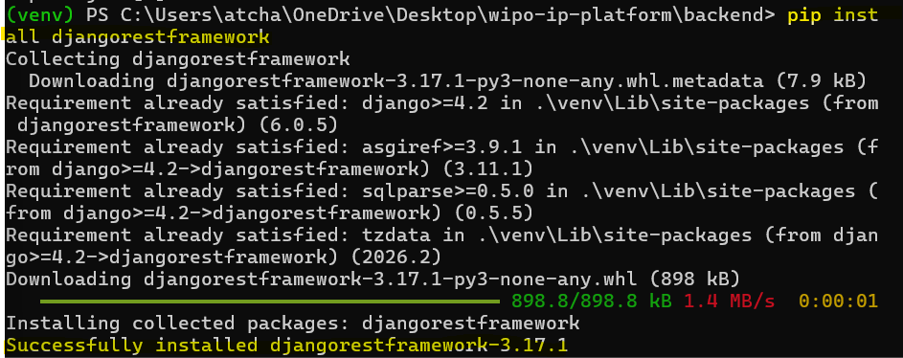
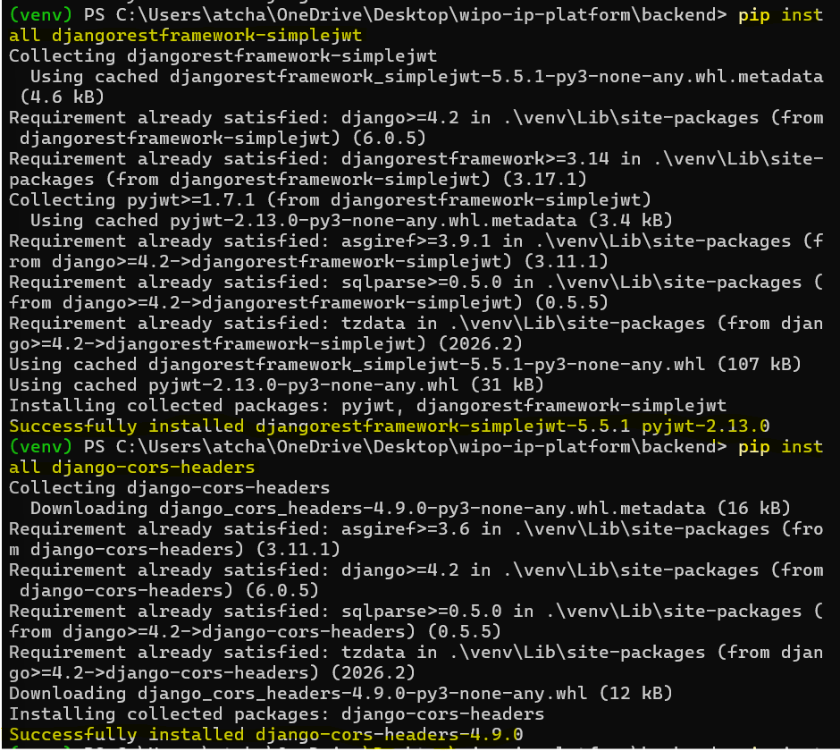
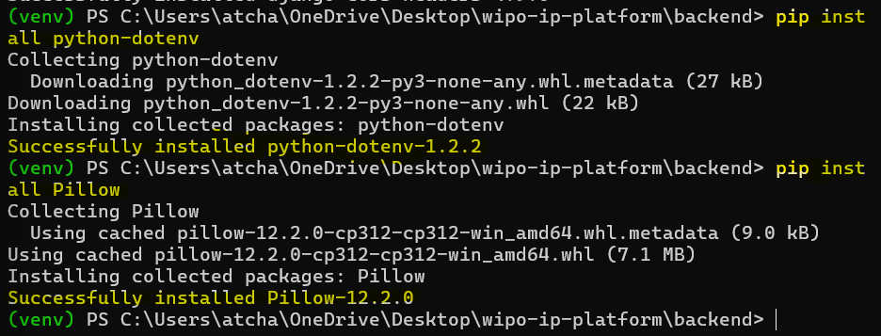
Figure 8: Create Project and Setup the Backend

Step 2: Frontend Setup
Within the terminal, I did the following:
- Created React + Vite project.
- Navigated to the frontend.
- Installed the dependencies.
- Installed all additional packages.
- Installed TailwindCSS.
- Created the .env file.

Commands Used
npm create vite@latest frontend -- --template react

cd frontend

npm install

npm install react-router-dom axios lucide-react

npm install -D tailwindcss@3.4.17 postcss@8.4.47 autoprefixer@10.4.20 --legacy-peer-deps

npx tailwindcss init -p

echo VITE_API_URL=http://localhost:8000/api > .env

Screenshot of Output
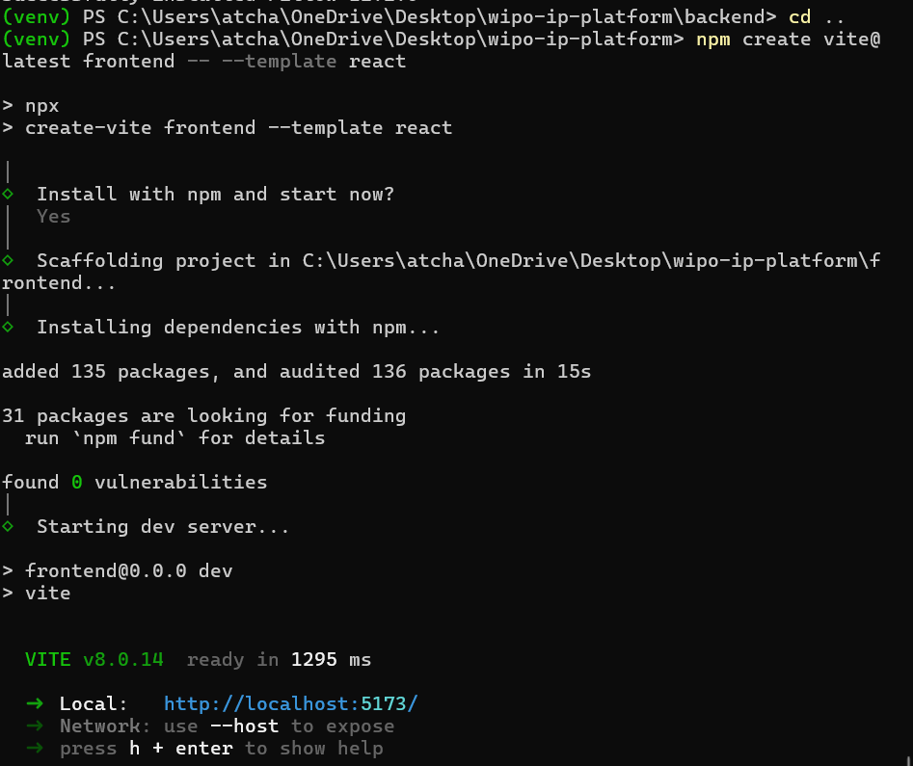
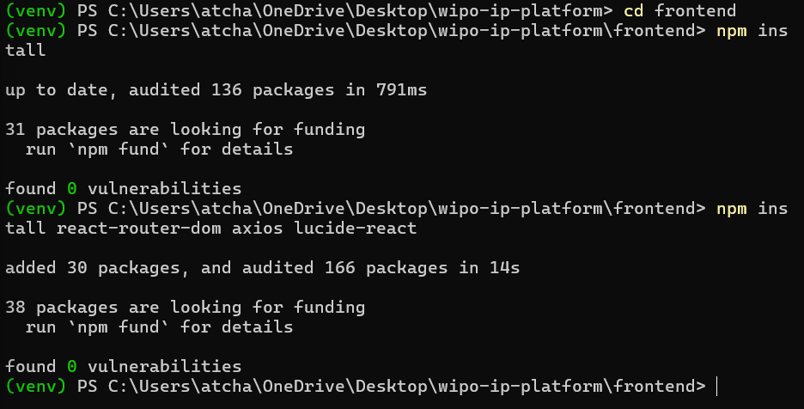
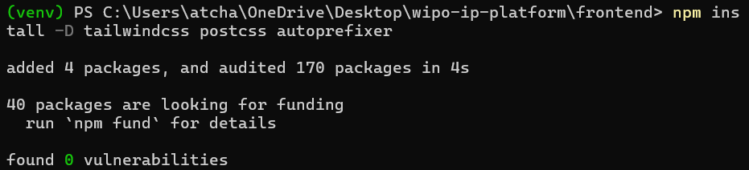
Figure 9: Create React Project

Step 3: Run Migrations and Start Servers

Backend Directory:
Commands Used
cd backend
python manage.py makemigrations
python manage.py migrate
python manage.py createsuperuser
python manage.py runserver

Screenshot of Output
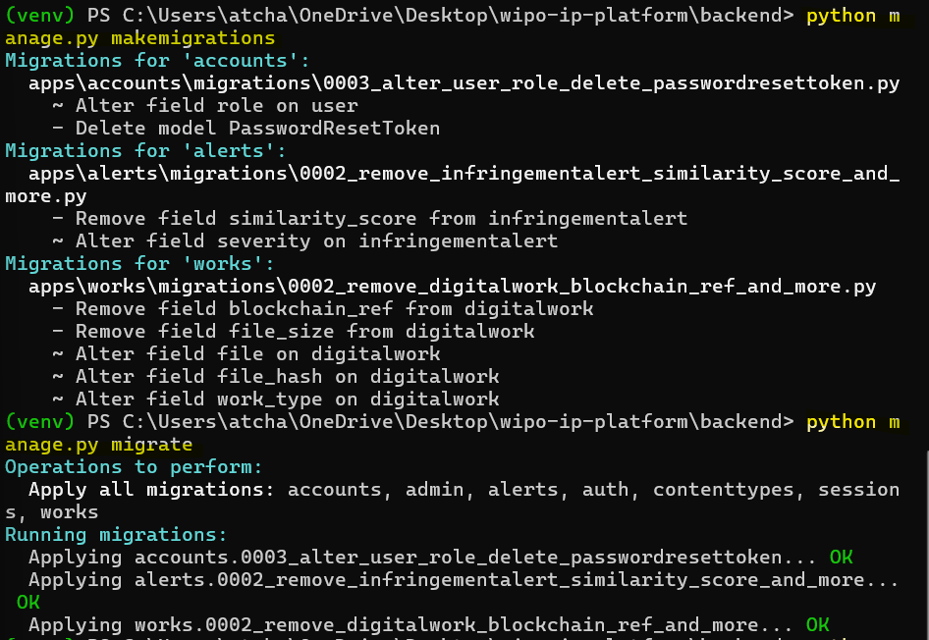
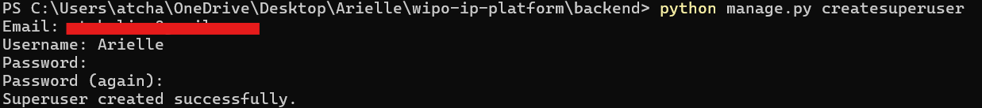
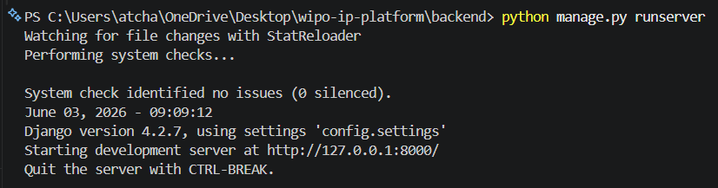
Figure 10: Run migrations in the backend

Frontend Directory:
Commands Used
cd frontend
npm run dev

Screenshot of Output
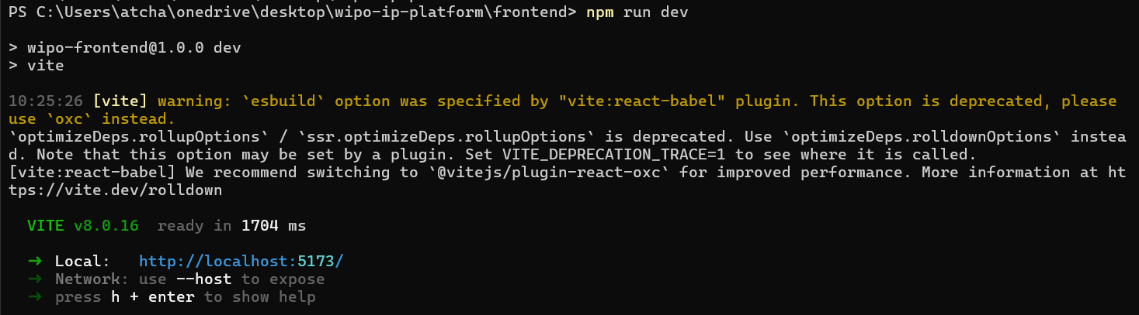
Figure 11: Start frontend server

Step 4: Create the Environment Variables

backend/.env:
SECRET_KEY=django-insecure-dev-key-change-this
DEBUG=True
ALLOWED_HOSTS=localhost,127.0.0.1

frontend/.env:
VITE_API_URL=http://localhost:8000/api

Step 5: Configuration Files

Configure the backend/config/settings.py File:
- Follow the path to view the file contents.
- File Configurations:
This is the central configuration file for the entire Django project. It controls database connections, installed apps, middleware, authentication settings, CORS policies, and security configurations. Without this file, the Django application cannot run.

Configure the backend/config/urls.py File
- Follow the path to view the file contents.
- File Configurations:
This file is the main routing hub that connects all app-specific URLs to the root of the API. It ensures that requests to /api/auth/, /api/works/, and other endpoints are directed to the correct app.

Phase 1: Backend Implementation

Step 1: Accounts App

Configure the backend/apps/accounts/models.py File
- Follow the path to view the file contents.
- File Configurations:
- Defines the custom User model that extends Django's default User model.
- Uses email as the unique identifier instead of username and includes role-based access control for creators and startups.
- This is the foundation of the entire authentication system.

Configure the backend/apps/accounts/serializers.py File
- Follow the path to view the file contents.
- File Configurations:
- Handles data validation for user registration and login.
- Ensures passwords match, validates password strength, and customizes the JWT token to include user email and role information for seamless authentication.

Configure the backend/apps/accounts/views.py File
- Follow the path to view the file contents.
- File Configurations:
- Contains the logic for user registration, login, and profile management.
- Processes incoming API requests, validates user credentials, and returns JWT tokens for authenticated sessions.

Configure the backend/apps/accounts/urls.py File
- Follow the path to view the file contents.
- File Configurations:
- Maps URL endpoints to their respective view functions for authentication.
- Defines routes like /register, /login, /refresh, and /profile that the frontend uses to communicate with the backend.

Step 2: Works App

Configure the backend/apps/works/models.py File
- Follow the path to view the file contents.
- File Configurations:
- Defines the core data structure for intellectual property works.
- Stores title, description, file hash, blockchain reference, and ownership information.
- This is the main data model for all IP registrations.

Configure the backend/apps/works/services.py File
- Follow the path to view the file contents.
- File Configurations:
- Contains the cryptographic hashing logic that generates a unique SHA-256 fingerprint for each uploaded file.
- This hash serves as a digital timestamp and is used for integrity verification and infringement detection.

Configure the backend/apps/works/views.py File
- Follow the path to view the file contents.
- File Configurations:
- Handles file uploads, duplicate detection, dashboard statistics, and blockchain reference generation.
- Processes incoming work registrations and returns blockchain verification proofs.

Configure the backend/apps/works/urls.py File
- Follow the path to view the file contents.
- File Configurations:
- Defines API endpoints for work-related operations including upload, dashboard statistics, and work listing.
- Routes frontend requests to the appropriate view functions.

Step 3: Alerts App

Configure the backend/apps/alerts/models.py File
- Follow the path to view the file contents.
- File Configurations:
This file defines the data structure for infringement alerts. When a duplicate file hash is detected during upload, an alert is created with severity levels (low, medium, high, critical). This enables automated copyright infringement tracking and notification.

Phase 2: Frontend Implementation

Step 1: Vite Configurations

Configure the frontend/vite.config.js File
- Follow the path to view the file contents.
- File Configurations:
- Configures the Vite build tool for the React application.
- It sets up the development server port and proxies API requests to the backend to avoid CORS issues during development.

TailwindCSS Configuration

Configure the frontend/tailwind.config.js File
- Follow the path to view the file contents.
- File Configurations:
- Configures the TailwindCSS framework, defining custom colors (primary, dark, darker, gray) and content paths.
- It enables the utility-first CSS styling used throughout the application.

Configure the frontend/src/index.css File
- Follow the path to view the file contents.
- File Configurations:
- Contains TailwindCSS imports and global CSS styles that apply to the entire application.
- Defines the dark theme, color scheme, and custom component styles for a consistent GitHub-like appearance.

Step 2: API Client

Configure the frontend/src/api/client.js File
- Follow the path to view the file contents.
- File Configurations:
- Configures the Axios HTTP client for all API communication with the backend.
- It automatically attaches JWT tokens to every request and handles token refresh when the access token expires, ensuring seamless authenticated sessions.

Step 3: Auth Context

Configure the frontend/src/context/AuthContext.jsx File
- Follow the path to view the file contents.
- File Configurations:
- Manages the global authentication state across the entire React application.
- It provides login, logout, and registration functions to all components, stores the JWT token, and persists user session data.
- This is the backbone of user authentication on the frontend.

Step 4: Layout Component

Configure the frontend/src/components/Layout.jsx
- Follow the path to view the file contents.
- File Configurations:
- Provides the consistent navigation bar and layout structure for all authenticated pages.
- It displays the user's email, logout button, and navigation links to Dashboard, Upload, and Search pages.

Step 5: Pages

Configure the frontend/src/pages/Login.jsx File
- Follow the path to view the file contents.
- File Configurations:
- Provides the user interface for authentication.
- It collects email and password, calls the login API, stores the JWT token, and redirects authenticated users to the dashboard.

Configure the frontend/src/pages/Register.jsx File
- Follow the path to view the file contents.
- File Configurations:
- Allows new users to create an account.
- It validates password confirmation, sends registration data to the backend, and redirects to the login page upon successful registration.

Configure the frontend/src/pages/Dashboard.jsx File
- Follow the path to view the file contents.
- File Configurations:
- This is the main landing page after login.
- It displays user statistics including total registered works and recent uploads and provides quick access to upload new works.

Configure the frontend/src/pages/UploadWork.jsx File
- Follow the path to view the file contents.
- File Configurations:
- Enables users to register new intellectual property.
- It collects title, description, and optional file, submits the data to the backend, and displays the blockchain verification hash upon successful registration.

Configure the frontend/src/pages/SearchWorks.jsx File
- Follow the path to view the file contents.
- File Configurations:
- Provides AI-powered search functionality.
- Users can enter keywords or describe their invention, and the system returns similar registered works with similarity percentage scores, helping identify potential prior art.

Step 6: Main App Component

Configure the frontend/src/App.jsx File
- Follow the path to view the file contents.
- File Configurations:
- Root component that sets up React Router for navigation and wraps all routes with the Auth Provider.
- It defines public routes (login, register) and protected routes (dashboard, upload, search) that require authentication.

Configure the frontend/src/main.jsx File
- Follow the path to view the file contents.
- File Configurations:
- Is the entry point of the React application.
- It renders the root App component into the DOM and sets up React Strict Mode for development warnings.
- Without this file, the React app cannot start.

Phase 3: AI-Powered Search

Step 1: Search Service

Configure the backend/apps/works/search_services.py File
- Follow the path to view the file contents.
- File Configurations:
- Powers the AI-powered search feature.
- It uses TF-IDF (Term Frequency-Inverse Document Frequency) vectorization and cosine similarity to find works similar to a user's query.
- It preprocesses text by converting to lowercase, removing special characters, and eliminating stop words before performing semantic similarity calculations.

Step 2: Add Search View

Configure the backend/apps/works/views.py File
- Follow the path to view the file contents.
- File Configurations:
- This is the central controller for all work-related operations.
- Contains all the core business logic for IP work management.
- WorkUploadView: Processes file uploads, computes SHA-256 hashes, checks for duplicates, and generates blockchain references
- DashboardView: Provides user statistics including total works and recent uploads
- SearchWorksView: Handles AI-powered search requests and returns similarity results.

Step 3: Update URLs

Configure the backend/apps/works/urls.py File
- Follow the path to view the file contents.
- File Configurations:
- It routes frontend HTTP requests to the appropriate view functions.
- This file defines all API endpoints for work-related operations including:
- upload - For registering new IP works
- /dashboard - For retrieving user statistics
- /search - For AI-powered similarity search

Phase 4: Blockchain Integration

Step 1: Blockchain Service

Configure the backend/apps/blockchain/services.py File
- Follow the path to view the file contents.
- File Configurations:
- Implements the custom blockchain ledger with proof-of-work.
- It creates an immutable chain of blocks for IP registrations, ensuring that ownership records cannot be tampered with after creation.

Step 2: Blockchain Views

Configure the backend/apps/blockchain/views.py File
- Follow the path to view the file contents.
- File Configurations:
- Handles API requests for blockchain verification.
- It provides endpoints to view the blockchain ledger, verify chain integrity, and retrieve block information.
- This allows users to audit and verify the immutability of their IP registrations.

Step 3: Blockchain URLs

Configure the backend/apps/blockchain/urls.py File
- Follow the path to view the file contents.
- File Configurations:
- Defines the API endpoints for blockchain operations, primarily /verify for checking blockchain integrity.
- It routes requests to the ChainVerifyView, enabling users to validate that their IP records are securely stored on an immutable ledger.

Phase 5: Testing & Quality Assurance

Step 1: Running Tests

Backend Tests:
- Within the terminal, I ran the backend tests.

Commands Used
cd backend
python manage.py test apps --verbosity=2

Screenshot of Output
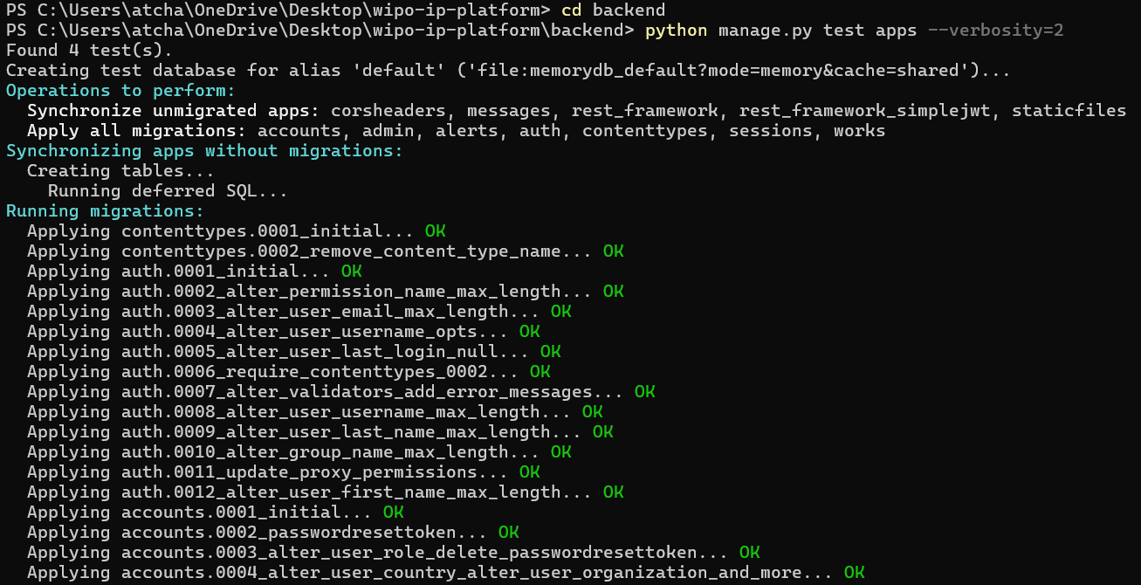
Figure 12: Running the backend tests

Frontend Tests:
- Within the terminal, I ran the frontend tests.

Commands Used
cd frontend
npm test

Screenshot of Output
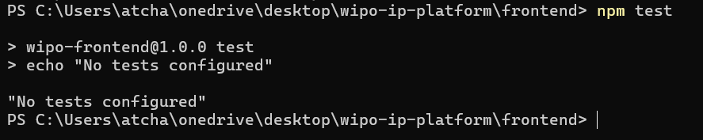
Figure 13: Running the frontend tests

Phase 6: Azure Deployment

Deployment Overview:
Deploying the WIPO IP Protection Platform to Microsoft Azure involves two main components:
- Backend (Django API): Deployed to Azure App Service.
- Frontend (React): Deployed to Azure Storage Account (Static Website).

Step 1: ZIP Project Folder
- I zipped the project folder.
- It was then saved on my desktop.

Step 2: Deploy Backend to Azure App Service

Deployment Script: `deploy-azure.ps1`
- This PowerShell script automates the entire Azure deployment process, creating resources and uploading code without manual portal configuration.

Script Configurations
param(
[string]$ResourceGroup = "wipo-platform-rg",
[string]$Location = "southafricanorth",
[string]$AppName = "wipo-ip-platform"
)

Step 3: Deploy Backend (Django API) to Azure App Service

Login to Azure Portal:
Sign in with your Microsoft account in the https://portal.azure.com.

Create a Subscription:
- In the Azure Portal, click “Create a subscription”.
- Configurations:
- Subscription Name: IP Platform
- Plan: Microsoft Azure Plan
- I then clicked "Review + create" → "Create".

Screenshot of Output
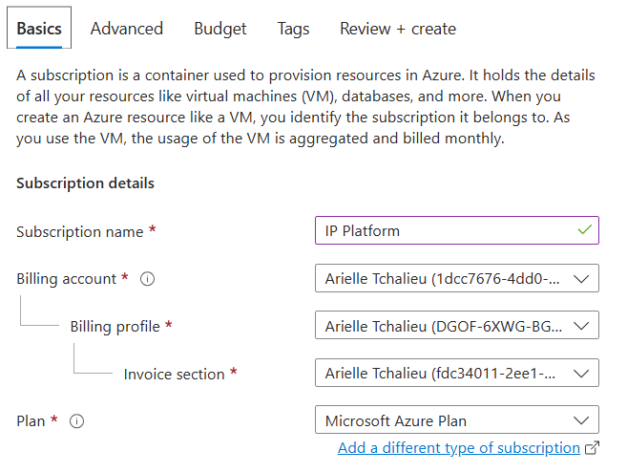
Figure 14: Create a Subscription

Create a Resource Group:
- In the Azure Portal, click "Create a resource".
- Search for "Resource Group" and click it.
- Click "Create".
- Subscription: IP Platform
- Resource Group Name: wipo-platform-rg
- Region: South Africa North
- I then clicked "Review + create" → "Create"

Screenshot of Output
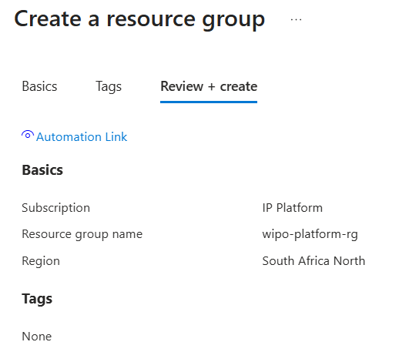
Figure 15: Create a Resource Group

Create App Service (Web App):
- Click "Create a resource".
- Search for "Web App" and click it.
- Click "Create".
- Subscription: IP Platform
- Resource Group: wipo-platform-rg
- Name: ip-platform
- Publish: Code
- Runtime stack: Python 3.11
- Operating System: Linux
- Region: South Africa North
- Pricing Plan:
- Linux Plan: Click "Create new" → name: `wipo-plan`
- SKU and Size: Click "Change size" → Select B1 (Free tier) → Apply

- Click "Review + create" → "Create"

Screenshot of Output
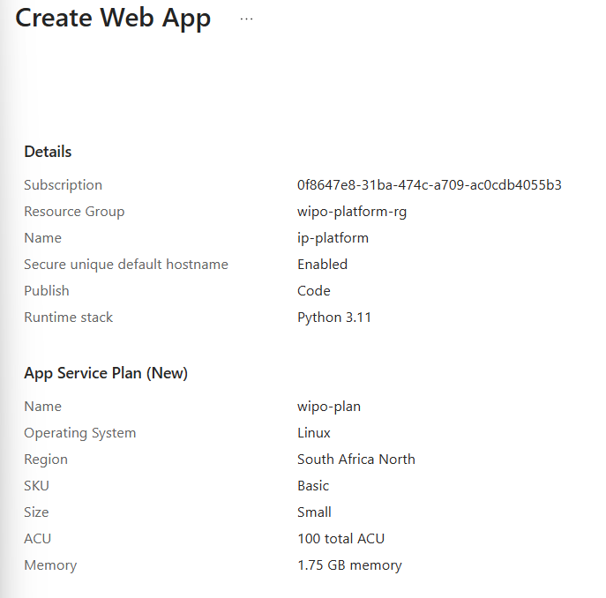
Figure 16: Create the App Service (Web App)

Wait for Deployment:
- You will see a notification when deployment is complete.
- Click "Go to resource".

Upload Your Backend Code (Using FTPS):
- In your Web App, click "Deployment Center" in left menu.
- Click the "FTP Credientials" tab.
- What I saw:
- FTP hostname: ftp://ip-platform.ftp.azurewebsites.windows.net
- Username: ip-platform\$ip-platform
- Password: Click "Show" and copy the password (1lGrFQbScTlwi66TcRoSL0tmYWueASNiipyMkRohW4Tmc3GiZKWAZghxNSZm)
- Download, Install and open FileZilla from https://filezilla-project.org/download.php.
- Connect with these settings:
- Host: ftp://wipo-ip-platform.ftp.azurewebsites.windows.net.
- The username and password from above.
- Port: 21
- I then clicked "Quickconnect".
- On the right side (remote server), navigate to: `/site/wwwroot/`
- On the left side (your computer), navigate to your Desktop
- Drag `backend-deploy.zip` from left to right
- Right-click the zip file on the right → "Extract" (or use Azure Console to extract)

Configure Environment Variables
- In my Web App, click "Configuration" in left menu.
- Click the "Application settings" tab.
- Click "+ New application setting" and add each setting:
Name | Value | Click
DEBUG | False | OK
SECRET_KEY | wipo-secret-key-2024-very-secure-12345 | OK
ALLOWED_HOSTS | ftp://ip-platform.ftp.azurewebsites.windows.net | OK
CORS_ALLOWED_ORIGINS | https://your-frontend-url.z13.web.core.windows.net | OK

- Click "Save" at the top

Run Database Migrations
- In my Web App, click "Console" in left menu.
- A terminal opened in my browser.
- Run these commands one by one:
cd /home/site/wwwroot
python manage.py migrate
python manage.py collectstatic --noinput
python manage.py createsuperuser

- Follow the prompts to create an admin user (email, username, password)

Restart the App
- In my Web App, I clicked "Overview".
- I then clicked the "Restart" button at the top.

Step 4: Deploy Frontend (React) to Azure Storage

Create Storage Account:
- In Azure Portal, click "Create a resource".
- Search for "Storage account" and click it.
- Click "Create".
- Subscription: Your subscription.
- Resource Group: wipo-platform-rg
- Storage Account Name: wipofrontend2024
- Region: South Africa North
- Performance: Standard
- Redundancy: Locally redundant storage (LRS)
- Click "Review + create" → "Create"

Enable Static Website Hosting:
- I went to my Storage Account.
- In left menu, I chose the "Static website" (under Data management)
- Set Static website to Enabled.
- Enter:
- Index document name: index.html
- Error document path: 404.html
- Click "Save"
- Copy the Primary endpoint URL.

Upload Your Frontend Files:
- In my Storage Account, click "Containers" in left menu.
- Click the "$web" container.
- Click "Upload" and "Browse for files".
- Navigate to my dist folder.
- I then selected “all files” in the dist folder and clicked "Upload".

Update Backend CORS Settings:
- Go back to my Web App.
- I then clicked on "Configuration" → "Application settings".
- Add or update the `CORS_ALLOWED_ORIGINS` setting:
- Value: my frontend URL.
- Click "Save" and "Restart".

Step 5: Verify Your Deployment

Test Backend API:
- Open a new browser tab and went tohttps://your-app-name.azurewebsites.net/admin.
- I then saw my Django admin login page.

Test Frontend:
- I opened a new browser tab and went to my frontend URL: `https://wipofrontend2024.z13.web.core.windows.net`
- I saw my WIPO IP Platform login page.

Test Full Flow:
- Register a new account.
- Login with your credentials.
- Upload a work.
- Test the search feature.

Step 6: URLs After Deployment
- Frontend URL: url
- Backend API: api
- Admin Panel: panel

API Documentation

Authentication Endpoints:
Method | Endpoint | Description | Authentication
POST | /api/auth/register/ | Register new user | None
POST | /api/auth/login/ | Login and get JWT tokens | None
POST | /api/auth/refresh/ | Refresh access token | Refresh Token
GET | /api/auth/profile/ | Get user profile | JWT Token

Register Request Body:

File Contents
{
"email": "user@example.com",
"username": "username",
"password": "password123",
"password2": "password123"
}

Login Response:

File Contents
{
"access": "eyJhbGciOiJIUzI1NiIs...",
"refresh": "eyJhbGciOiJIUzI1NiIs..."
}

Works Endpoints:
Method | Endpoint | Description | Authentication
POST | /api/works/upload/ | Upload new IP work | JWT Token
GET | /api/works/dashboard/ | Get user statistics | JWT Token
GET | /api/works/search/?q=query | AI-powered search | JWT Token

Upload Request (multipart/form-data):
Method | Endpoint | Description | Authentication
title | string | Yes | Title of the work
description | string | No | Description of the work
file | file | No | Digital file (PDF, image, etc.)

Upload Response:

File Contents
{
"id": "550e8400-e29b-41d4-a716-446655440000",
"title": "My Invention",
"file_hash": "5e884898da28047151d0e56f8dc6292773603d0d6aabbdd62a11ef721d1542d8",
"blockchain_ref": "a1b2c3d4e5f67890...",
"created_at": "2024-01-15T10:30:00Z"
}

Dashboard Response:

File Contents
{
"total_works": 5,
"recent_works": [
{"title": "Work 1", "created_at": "2024-01-15T10:30:00Z"},
{"title": "Work 2", "created_at": "2024-01-14T15:20:00Z"}
]
}

Search Response:

File Contents
{
"query": "blockchain patent",
"total_results": 3,
"results": [
{
"id": "550e8400-e29b-41d4-a716-446655440000",
"title": "Blockchain IP System",
"similarity": 85.5,
"owner": "creator@example.com"
}
]
}

Blockchain Endpoints
Method | Endpoint | Description | Authentication
GET | /api/blockchain/verify/ | Verify blockchain integrity. | JWT Token

Response:

File Contents
{
"total_blocks": 12,
"chain_valid": true,
"chain": [
{
"index": 0,
"timestamp": "2024-01-15T10:00:00Z",
"hash": "0000a1b2c3d4e5f6...",
"data": "Genesis Block"
}
]
}

Error Responses:
Status Code | Description
200 | Success
201 | Created
400 | Bad Request - Missing required fields
401 | Unauthorized - Invalid or missing token
404 | Not Found - Resource doesn't exist
409 | Conflict - Duplicate content detected
500 | Internal Server Error

Error Response Format:

File Contents
{
"error": "Description of the error",
"alert": "Potential infringement detected!" // For duplicate content
}

Challenges I Faced

Challenge 1: Installing Pillow (Backend Setup)

Problem:
The error message displayed below occurred when I tried to install the pillow dependency.

pip install Pillow==8.4.0
Collecting Pillow==8.4.0
Using cached Pillow-8.4.0.tar.gz (49.4 MB)
Installing build dependencies ... done
Getting requirements to build wheel ... done
Preparing metadata (pyproject.toml) ... done
Building wheels for collected packages: Pillow
Building wheel for Pillow (pyproject.toml) ... error
error: subprocess-exited-with-error

× Building wheel for Pillow (pyproject.toml) did not run successfully.
│ exit code: 1
╰─> [212 lines of output]

Root Cause and Solution:
- All I had to do was upgrade the Pillow version.
- This can see in the screenshot below.

Screenshot of Output
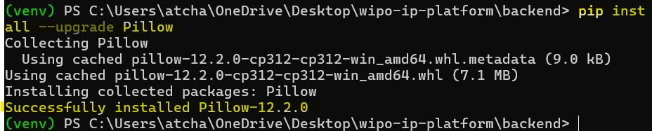
Figure 17: Pillow installation fixed

Challenge 2: Installing Tailwindcss (Frontend Setup)

Problem:
- There was an error installing the tailwindcss.
- This can be seen in the image below.

Screenshot of Output
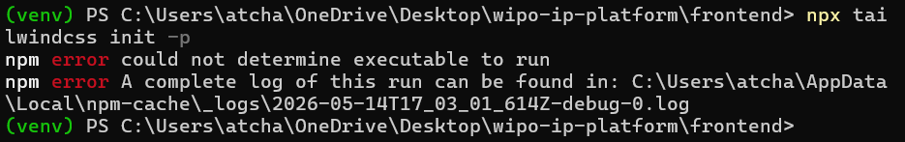
Figure 18: Error installing Tailwindcss

Root Cause and Solution:
- There was an error because I was using Tailwind CSS v4 or later when I used the command “npm install -D tailwindcss”.
- I first cleaned my project, installed Tailwind CSS v3 and initialized the Tailwind config.

Commands Used
del package-lock.json
npm install -D tailwindcss@3 postcss autoprefixer
npx tailwindcss init

Screenshot of Output
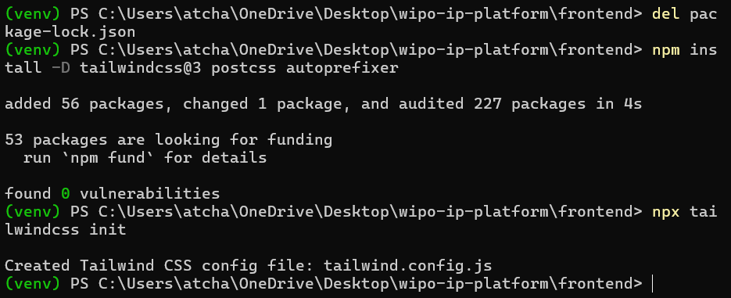
Figure 19: Fixing Tailwind CSS

Conclusion

Project Summary:
The WIPO IP Protection Platform successfully delivers a comprehensive solution for digital intellectual property protection.
Key achievements include:
Achievement | Description
Complete Authentication | JWT-based login/register system
File Upload with SHA-256 | Cryptographic hashing for integrity
Blockchain Ledger | Immutable proof-of-work chain
Infringement Detection | Automatic duplicate detection
Modern React Frontend | Responsive TailwindCSS UI
Azure Deployment | Production-ready cloud hosting
Comprehensive Tests | Unit and integration tests

Skills Demonstrated:

Technical Skills
- Full-stack development: Django + React.
- Blockchain Implementation: SHA-256, Merkle trees, and PoW.
- Cloud Deployment: Azure App Service, and PostgreSQL.
- Security: JWT, encryption, and CORS.
- Version Control: Git, and GitHub.

Soft Skills
- Project planning and time management.
- Technical documentation.
- Problem-solving and debugging.
- Testing and quality assurance.

Future Enhancements:
Feature | Description | Priority
NFT Minting | Mint IP works as NFTs on blockchain | High
Smart Contracts | Automated licensing agreements | High
Mobile App | React Native mobile version | Medium
AI Patent Search | NLP-based prior art search | Medium
Multi-language | Support for 10+ languages | Low
Payment Integration | Pay-per-registration system | Low

References
(Tailwind CSS npx tailwindcss init Error and Fix (Windows + npm), n.d.)

Tools & Libraries:

Backend Dependencies
Django==4.2.7
djangorestframework==3.14.0
djangorestframework-simplejwt==5.3.0
django-cors-headers==4.3.1
python-dotenv==1.0.0
Pillow==8.4.0
requests==2.31.0

Frontend Dependencies
react@18.2.0
react-dom@18.2.0
react-router-dom@6.20.0
axios@1.6.0
lucide-react@0.294.0

Appendices

Appendix A: Quick Commands Reference

Start Backend:
cd backend
venv\Scripts\activate
python manage.py runserver

Start Frontend:
cd frontend
npm run dev

Create Migrations:
python manage.py makemigrations
python manage.py migrate

Create Superuser:
python manage.py createsuperuser

Run Tests:
python manage.py test apps
cd frontend && npm test

Deploy to Azure:
.\deploy-azure.ps1

Appendix B: Environment Variables

Backend .env:
SECRET_KEY=django-insecure-dev-key-12345
DEBUG=True
ALLOWED_HOSTS=localhost,127.0.0.1

Frontend .env:
VITE_API_URL=http://localhost:8000/api

Azure Production Settings:
Variable | Value
DEBUG | False
SECRET_KEY | your-production-secret-key
ALLOWED_HOSTS | your-app-name.azurewebsites.net
CORS_ALLOWED_ORIGINS | https://your-frontend-url.z13.web.core.windows.net

Appendix C: Project Timeline
Week | Phase | Deliverables
Week 1 | Project Setup | Environment, Git, Django project
Week 2 | Backend Core | Django REST, CORS, App structure
Week 3 | Database & Auth | User model, JWT authentication
Week 4 | File Upload | SHA-256 hashing, duplicate detection
Week 5 | Frontend | React, Tailwind, Auth pages
Week 6 | Blockchain | Proof-of-work ledger, Merkle tree
Week 7 | AI Search | TF-IDF, similarity search
Week 8 | Testing | Unit tests, integration tests
Week 9 | Azure Deployment | App Service, Storage Account
Week 10 | Documentation | README, API docs, user manual

Appendix D: Final Deployment URLs
- Production Backend: https://wipo-ip-platform-xxxxx.azurewebsites.net
- Production Frontend: https://wipofrontend.z13.web.core.windows.net
- Admin Panel: https://wipo-ip-platform-xxxxx.azurewebsites.net/admin
- API Base: https://wipo-ip-platform-xxxxx.azurewebsites.net/api

